Cypher lab 1

1. List the lastName for the student whose firstName is Ana

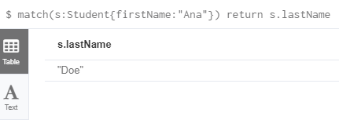

1. List all attributes of students whose lastName is Doe

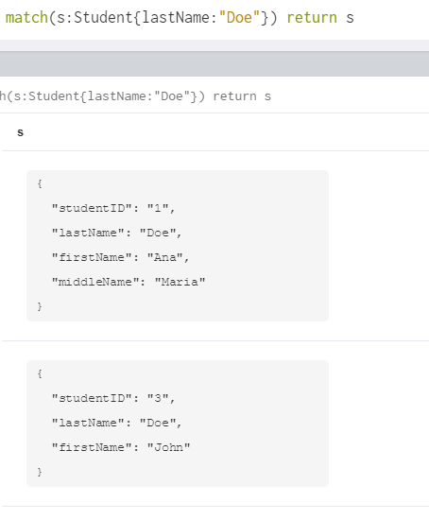

1. Count the number of Students with lastName “Doe”

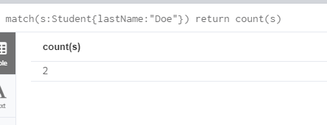

1. Count the numbers of Students and display the result using an alias as NumStudents

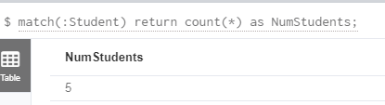

1. Update Student with id 2 to have the middleName Sean

MATCH (s:Student {studentID: '2'}) SET s.middleName = 'Sean' RETURN s

1. Update Student with id 2 to have an age attribute and set it to 19

MATCH (s:Student {studentID: '2'}) SET s.age = 19 RETURN s

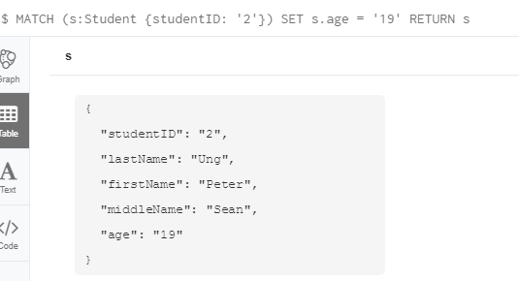

1. Update Student with id 1 to have an age attribute and set it to 30

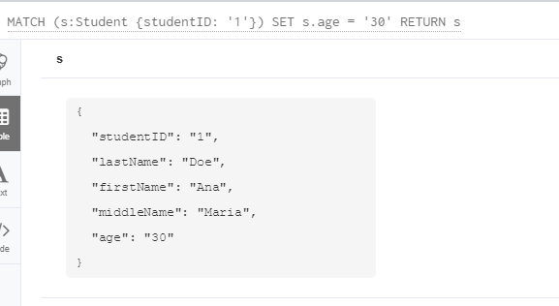

1. Update Students with ids 3, 4 and 5 to have an age of 18

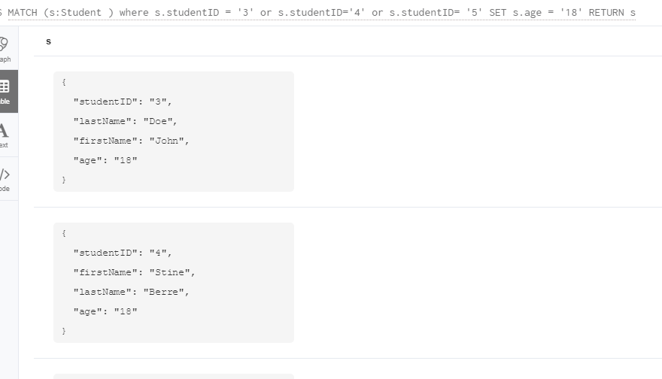

1. What age is the oldest student

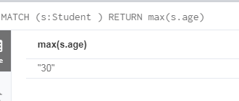

1. What is the name of the eldest student

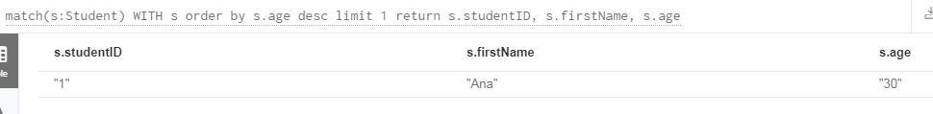

1. Find the youngest student(s), list their id, firstNames and age

